**Cloud Assignment**

**Create a virtual network with 2 subnets. Each subnet should have 16 Ips only.**

To create an Azure Virtual Network using the Azure Portal:

1. Navigate and sign in to the [Azure portal](https://portal.azure.com/).
2. Select **Create a resource** on the Azure Portal homepage.
3. On the **Create a resource** page, search the marketplace for *virtual network* and select it from the results.
4. On the **Virtual Network** page, select **Create**.
5. On the **Create virtual network** page, configure the information in the **Basics** tab.

* Subscription: select the subscription to bill the resource against
* Resource group: create a new resource group or choose an existing one
* Name: enter **________**
* Region: select the **East US** region

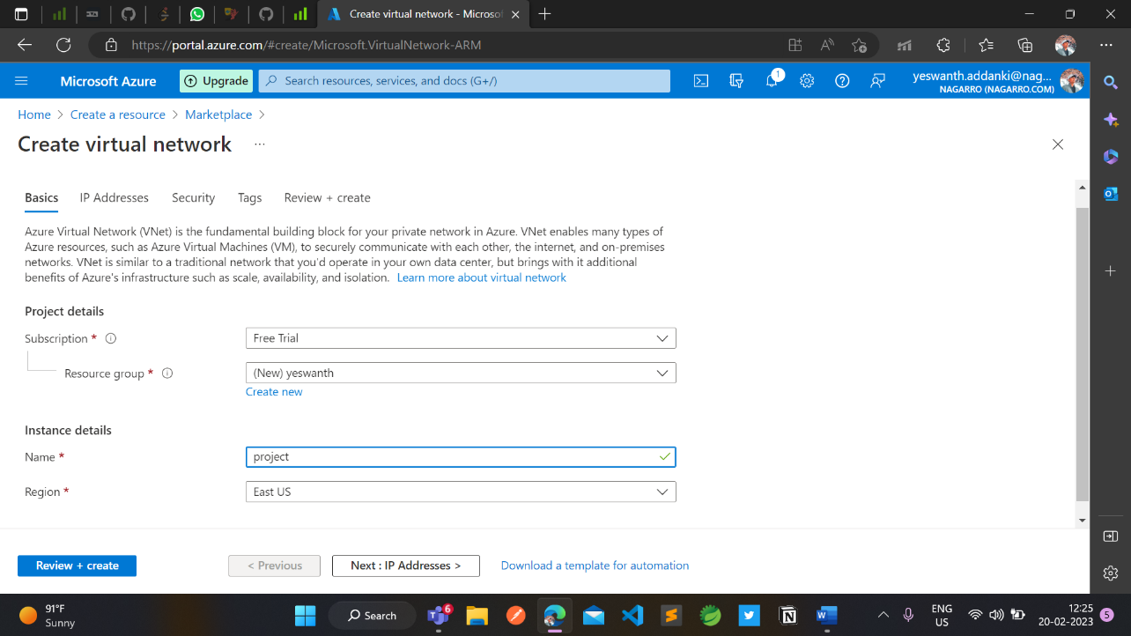

1. Select **Next: IP Addresses** button at the bottom of the page.
2. In the **IPv4 address space** section, Azure has pre-populated the address space **10.1.0.0/16**. Select this existing address space and change it to **10.100.0.0/16**.
3. If you want to add subnets now, select **+ Add subnet**, then enter the subnet name **snet-subnet1** and an address range of **10.50.25.0/24**.

Deployment

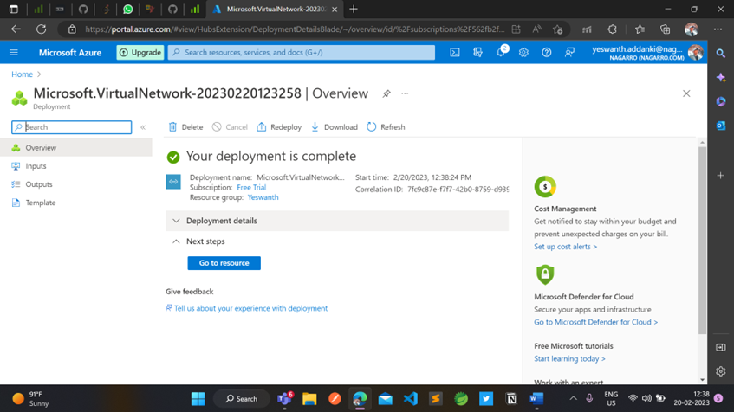

**Inside one of the subnets, create a VM and deploy an application code inside it and it should leverage the database on the cloud (any existing application created by you before)**

1. Enter virtual machines in the search.
2. Under **Services**, select **Virtual machines**.
3. In the **Virtual machines** page, select **Create** and then **Azure virtual machine**. The **Create a virtual machine** page opens.
4. Under **Instance details**, enter ____for the **Virtual machine name** and choose Windows Server 2019 Datacenter - Gen 2 for the **Image**. Leave the other defaults.

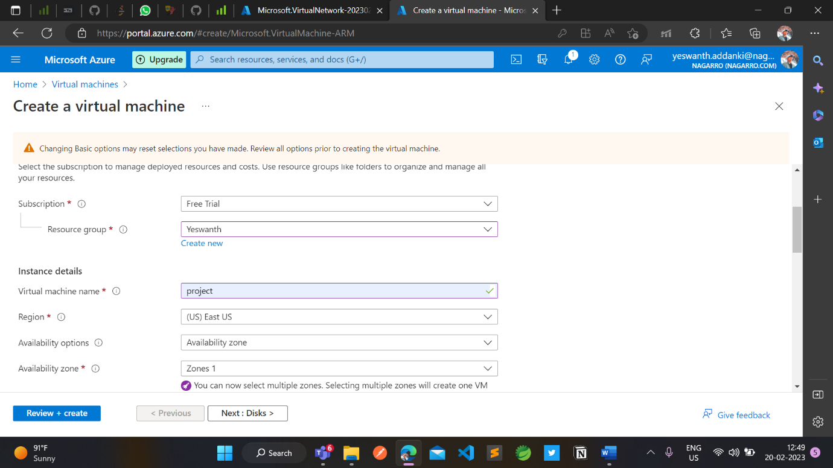

**5.** Under **Administrator account**, provide a username, such as azureuser and a password. The password must be at least 12 characters long

6.Under **Inbound port rules**, choose **Allow selected ports** and then select **RDP (3389)** and **HTTP (80)** from the drop-down

After validation runs, select the **Create** button at the bottom of the page.

After deployment is complete, select **Go to resource**.

On the overview page for your virtual machine, select the **Connect** > **RDP**.

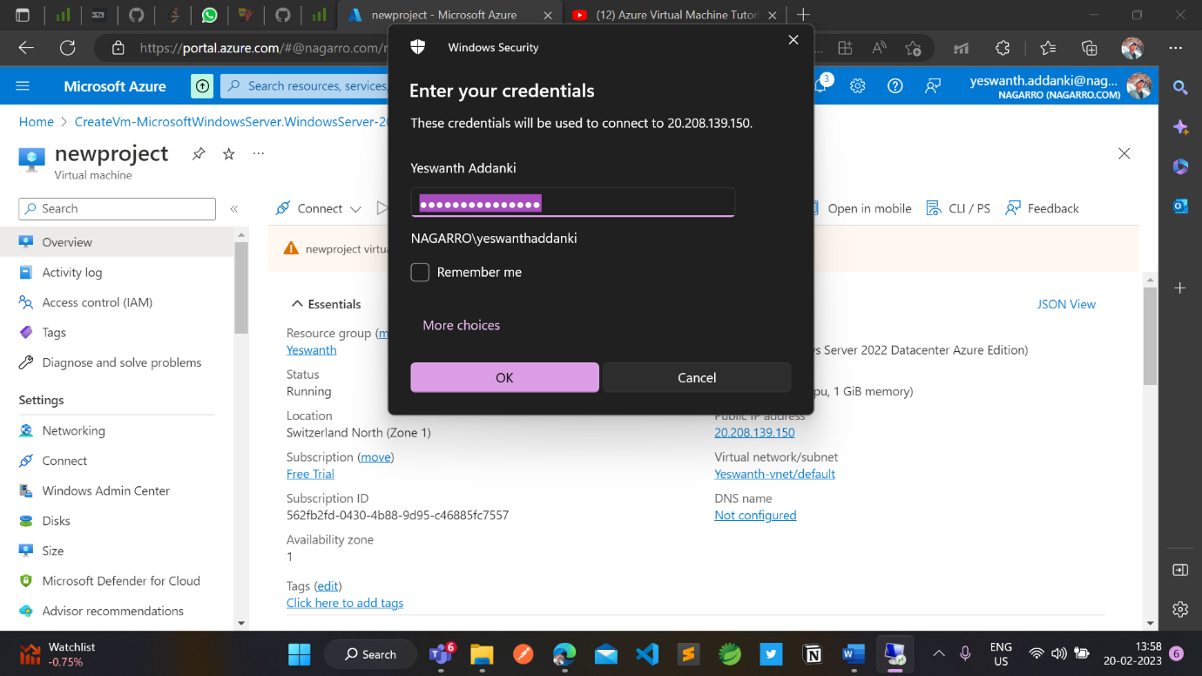

Software’s installed in VM

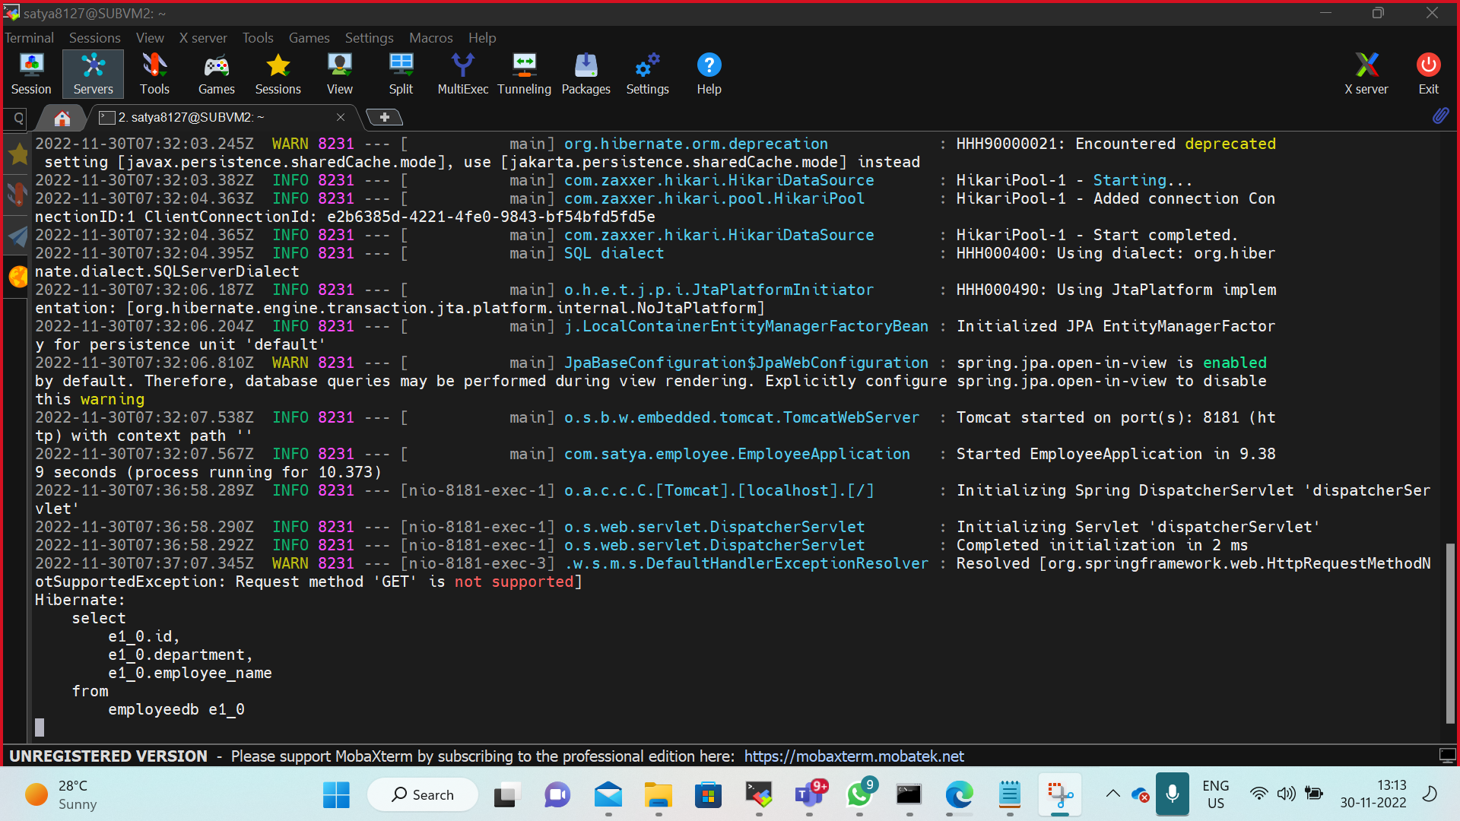

**Output of springapp in VM**

**Deploy the same application to Azure App Service. It should also leverage the database on the cloud**.

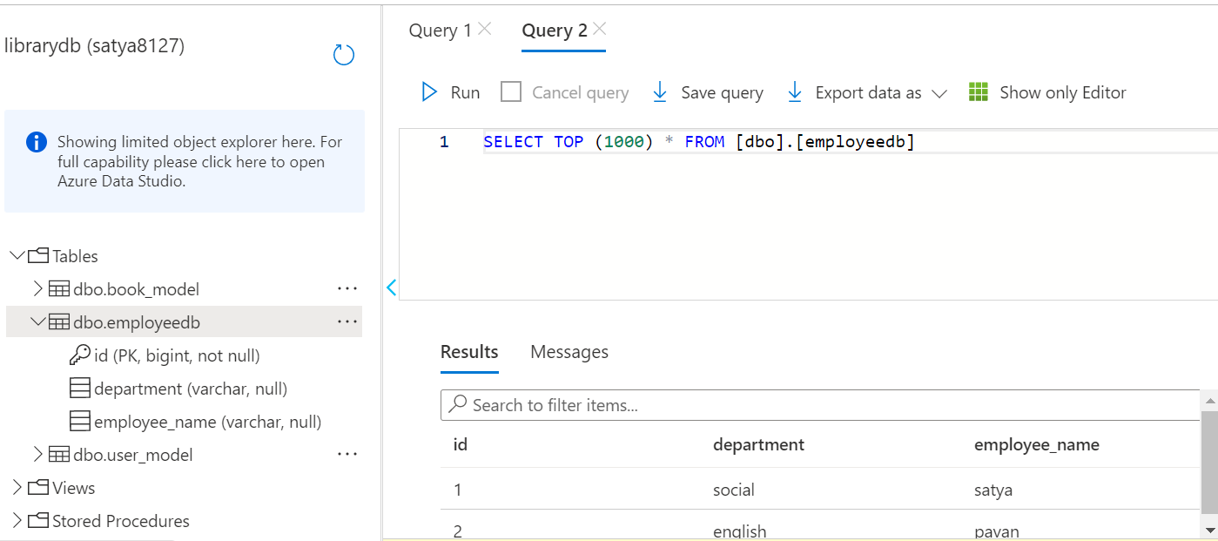

**Create the AKS cluster (2 nodes, smallest size VM) and deploy any two services on it. Services should be accessible from the internet.**

* **Subscription**: Select an Azure subscription.
* **Resource group**: Select **Create new**. Enter a unique name for the resource group, such as *satya8127*, then choose **OK**.
* **Location**: Select a location, such as **East US**.
* **Cluster name**: Enter a unique name for the AKS cluster, such as clus2.
* **DNS prefix**: Enter a unique DNS prefix for your cluster, such as *clus*.
* **Linux Admin Username**: Enter a username to connect using SSH, such as *azureuser*.
* **SSH RSA Public Key**: Copy and paste the *public* part of your SSH key pair (by default, the contents of *~/.ssh/id_rsa.pub*).

**Connect to the cluster**

**Create an Azure function that should trigger as soon as you upload a file in the blob storage. Function should be able to print the name of the file uploaded in the function.**

**Create an Azure Functions project**

Click the **Create New Project…** icon in the **Azure: Functions** panel.

You will be prompted to choose a directory for your app. Choose an empty directory.

You will then be prompted to select a language for your project. Choose .

**Create a function**

Click the **Create Function…** icon in the **Azure: Functions** panel.

You will be prompted to choose a template for your function. We recommend HTTP trigger for getting started.

**Run your function project locally**

Press **F5** to run your function app.

The runtime will output a URL for any HTTP functions, which can be copied and run in your browser's address bar.

To stop debugging, press **Shift + F5**.

**Deploy your code to Azure**

Click the **Deploy to Function App…** () icon in the **Azure: Functions** panel.

When prompted to select a function app, choose triggerfun.